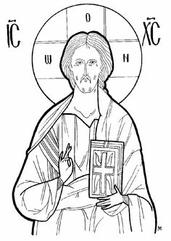
Christ the Saviour Orthodox Church
10000 State Road - North Royalton, Ohio 44133
Will be celebrating their 50th anniversary of Founding.
We cordially invite you to send greetings or to sponsor one
of the following ads.

DEADLINE FOR RETURN: JUNE 30, 2014
_______ $125.00 Full page Glossy Inside Cover page (7 ½ wide x 10 high)
_______ $ 100.00 Full page (7 ½ wide x 10 high)
_______ $ 60.00 Half page (7 ½ wide x 5 high)
_______ $ 30.00 Quarter page (3 ½ wide x 5 high)
_______ $ 20.00 Business Card (3 ½ wide x 2 high)
If you would like to include a black & white photo in your ad, please include an additional donation of $5.00. Please submit your ad in ‘camera-ready’ black & white (PDF) format. Sizing templates are provided on the other side of this page. Additional forms can be found at our church website at www.christsaviour.weebly.com.
Name: ____________________________________________________________
Phone: _________________________
Email address: _____________________________________________________

Please make your check payable to: CHRIST the SAVIOUR ORTHODOX CHURCH
You may email your ad to: christ.saviour@live.com
Mail to: Penney Royko
38119 Parkway Blvd
Willoughby, OH 44094
440-946-5762

Thank you for your patronage and support of Christ the Saviour Orthodox Church!

